Texas Coastal Nutrient Input Repository - Task 3 Report Lavaca Bay Water Quality Responses to Nutrient Loading

Michael Schramm 1

1 Research Specialist, Texas Water Resources Institute, Texas A&M AgriLife Research

December 1, 2021

Texas Water Resources Institute

Texas A&M Agrilife

College Station, TX



This project was funded by a Texas Coastal Management Program grant approved by the Texas Land Commissioner, providing financial assistance under the Coastal Zone Management Act of 1972, as amended, awarded by the National Oceanic and Atmospheric Administration (NOAA), Oﬀice for Coastal Management, pursuant to NOAA Award No. NA21NOS4190136. The views expressed herein are those of the author(s) and do not necessarily reflect the views of NOAA, the U.S. Department of Commerce, or any of their subagencies.

Table of Contents

Table of Figures

Table of Tables

Abbreviations

| Acronym | Meaning |
| --- | --- |
| GAM | Generalized Additive Model |
| N+N | Nitite+Nitrate |
| NO3-N | Nitrate-Nitrogen |
| QAPP | Quality Assurance Project Plan |
| TCEQ | Texas Commission on Environmental Quality |
| TKN | Total Kjeldahl Nitrogen |
| TP | Total Phosphorus |
| TWDB | Texas Water Development Board |
| TxRR | Texas Rainfall-Runoff Model |
| USGS | United States Geological Survey |

# Introduction

Lavaca Bay is a secondary bay in the Matagorda Bay system located centrally along the Texas Gulf coast, roughly halfway between the cities of Houston and Corpus Christi (Figure ). Although Lavaca Bay has faced substantial challenges associated with legacy contaminants, general water quality such as dissolved oxygen (DO), nutrients, and biological parameters have indicated that ambient conditions in Lavaca Bay meet state water quality standards. However, local stakeholders have voiced concerns about potentially degrading conditions in Lavaca Bay. Long-term declines in the abundance of sensitive benthic fauna in Lavaca Bay are linked to increases in salinity and reductions in freshwater inflows (Beseres Pollack et al. 2011; Palmer and Montagna 2015; Montagna et al. 2020). More recently, Bugica et al. (2020) identified long-term monotonic increasing trends in Total Phosphorus (TP), Orthophosphate (PO4-3), Total Kjeldahl Nitrogen (TKN), and chlorophyll-*a* concentrations at sites within Lavaca Bay. Significant decreases in pH at all sites assessed by Bugica et al. (2020) in Lavaca Bay also point to long-term decreases in freshwater inflow and a resulting increase in salinity. Although no changes in DO concentrations were identified, the increases in nutrient parameter concentration are concerning as potential precursors to eutrophication. The potential for negative impacts induced by eutrophication is a especially concerning given the significant declines observed in benthic fauna abundance, biomass, and diversity within Lavaca Bay (Beseres Pollack et al. 2011).

There are multiple ongoing efforts between local entities and state and federal agencies to address water quality impairments and concerns in the riverine portions of the Lavaca Bay watershed (Jain et al. 2018; Schramm et al. 2018; Berthold et al. 2021). On a statewide scale these types of efforts have not demonstrated desired success (Schramm et al. 2022). Changes and trends in estuarine water quality parameters are non-linear and confounded by short and long-term changes in precipitation and runoff (Wazniak et al. 2007; Lloyd et al. 2014). Water quality conditions should be evaluated relative to changes in environmental drivers such as precipitation and discharge to understand the effects of land use management and changes in nutrient loading on in-estuary water quality. This report presents methodology and results for assessing nonlinear linkages between selected water quality parameters in Lavaca Bay and freshwater inflows and nutrients loading from the Lavaca Bay watershed.

# Methods

## Study Area and Data

Lavaca Bay is 190 km2 with the majority of freshwater inflow provided by the Lavaca-Navidad river system (Figure ). The Garcitas-Arenosa, Placedo Creek, and Cox Bay watersheds provide additional freshwater inflows. The watershed land area for Lavaca Bay is 8,149 km2. The Lavaca-Navidad river watershed is 5,966 km2, or approximately 73% of the watershed area. Discharge from the Navidad River is regulated by Lake Texana which has been in operation since 1980. Lake Texana provides 170,000 acre-feet of water storage and discharges into the tidal section of the Navidad River which ultimately joins the tidal section of the Lavaca River 15 km upstream of the confluence with the Bay.

Daily inflow to Lavaca Bay was estimated by combining mean daily discharge from USGS-08164000 (Lavaca River) and USGS-08164525 (Lake Texana). Mean daily discharges from USGS-08164000 were obtained from the United States Geologic Survey (USGS) National Water Information System (NWIS) using the “dataRetrieval” R package (De Cicco et al. 2022). Mean daily discharges for USGS-0816425 were obtained from the Texas Water Development Board (TWDB) (April 21, 2022 email from R. Neupane, TWDB). Daily nutrient loads were modeled at USGS-08164000 and USGS-08164525 using a Generalized Additive Model (GAM) relating time, season, and discharge to nutrient concentrations. The development of daily loads is further described in INSERT REPORT. Water quality data collected between January 2005 and December 2020 was obtained for three sites (TCEQ-13563, TCEQ-13383, TCEQ-13384) in Lavaca Bay from the Texas Commission on Environmental Quality’s (TCEQ) Surface Water Quality Monitoring Information System (SWQMIS; <https://www80.tceq.texas.gov/SwqmisWeb/public/crpweb.faces>). Data housed in SWQMIS are collected under projects with an approved Quality Assurance Project Plan (QAPP) and under sample collection and lab methods procedures outlined by TCEQ’s procedures manuals ((<https://www.tceq.texas.gov/waterquality/monitoring/swqm_guides.html>). The QAPP and procedures manuals ensure consistent collection and analytical methods are applied between samples collected among different entities and different projects.

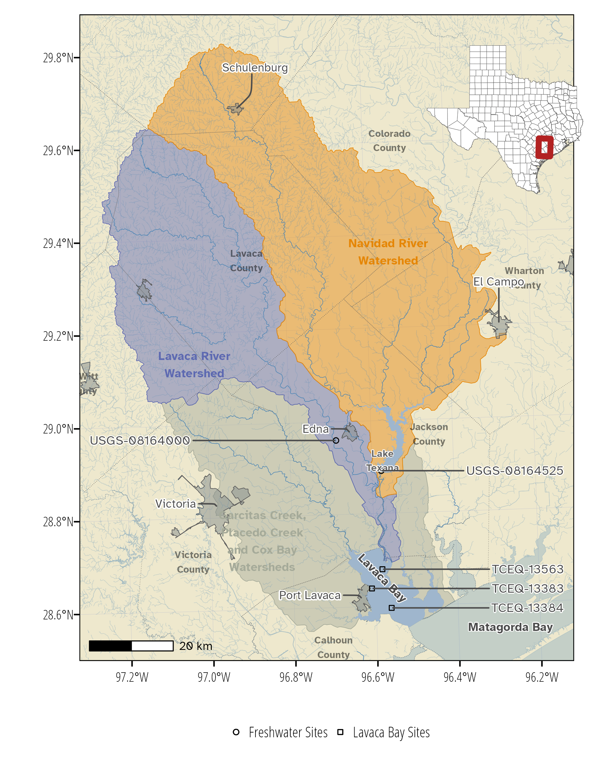

Figure . Study area map.

Table . Summary statistics of water quality parameters at Lavaca Bay sites.

| **Station ID** | **Station Description** |  | **Chlorophyll-a (µg/L)** | |  | **Dissolved Oxygen (mg/L)** | |  | **Nitrite+Nitrate (mg/L)** | |  | **Total Kjeldahl Nitrogen (mg/L)** | |  | **Total Phosphorus (mg/L)** | |
| --- | --- | --- | --- | --- | --- | --- | --- | --- | --- | --- | --- | --- | --- | --- | --- | --- |
|  | **Mean (SD)** | **N** |  | **Mean (SD)** | **N** |  | **Mean (SD)** | **N** |  | **Mean (SD)** | **N** |  | **Mean (SD)** | **N** |
| TCEQ-13383 | LAVACA BAY AT SH 35 |  | 9.43 (5.31) | 47 |  | 7.22 (1.35) | 55 |  | 0.07 (0.15) | 51 |  | 0.94 (0.49) | 45 |  | 0.11 (0.05) | 47 |
| TCEQ-13384 | LAVACA BAY AT Y AT CM 66 |  | 8.22 (6.44) | 46 |  | 7.51 (1.32) | 54 |  | 0.06 (0.08) | 52 |  | 0.76 (0.40) | 48 |  | 0.08 (0.03) | 51 |
| TCEQ-13563 | LAVACA BAY AT CM 22 |  | 9.67 (5.33) | 49 |  | 7.91 (1.34) | 56 |  | 0.09 (0.13) | 53 |  | 0.94 (0.37) | 49 |  | 0.13 (0.06) | 50 |

## Linking Watershed Loads to Estuary Water Quality

We explored relationships between watershed nutrient loads and nutrient concentrations at each of the three monitoring sites in Lavaca Bay. The general form of the GAM models were:

where *μ* is the conditional expected response (nutrient concentration), *g()* is the log link, *α* is the intercept, and *fn* are smoothing functions. The response variable was modeled as Gamma distributed with mean *μ* and scale *λ*. *f1(ddate)* is decimal date smoothed with a thin-plate regression spline, *f2(yday)* is the numeric day of year smoothed with a cyclic cubic regression spline, *f3(Q)* is total daily watershed discharge and *f4(Load)* is total NO3-N or TP watershed load.

The relatively large impact of flow variability on nutrient loading creates a challenge for disentangling the impacts of flow and load (Murphy et al. 2022). Instead of using raw freshwater flow and nutrient loading values, these values were replaced by seasonally adjusted flow and flow-adjusted nutrient loads as described by Murphy et al. (2022). In short, a seasonal GAM was fit to daily flow values and the model residuals were used in *f3(Q)* and a GAM for nutrient loads was fit to daily streamflows with the model residuals used in *f4(Load)*.

By comparing the model fits between the three GAMs, we evaluated if variance in Lavaca Bay water quality parameters are well explained by only temporal predictors (Equation (1)) or if the freshwater inflow (Equation (2)) and nutrient loading (Equation (3)) explain additional water quality parameter variation. To compare models, we used an information theoretic approach utilizing corrected Akaike information criterion (AICC) to calculate model probabilities as a measure of strength of evidence (Burnham et al. 2011).

A summary of models used for each parameter is shown in Table . Daily NO3-N loading was used as a predictor for Nitrite+Nitrate (N+N) concentrations, daily TP loading was used as a predictor for TP concentration, both NO3-N and TP were used for DO and chlorophyll-a concentrations. TKN models were restricted to temporal and flow terms because neither total nitrogen or TKN loadings were available. Currently, insufficient data is available to estimate organic nitrogen loadings in the watershed but with ongoing monitoring projects incorporating a full suite of nutrient parameters, we anticipate the development of these loads in future years.

Table . Specification of GAM model structure.

| **Water Quality Response Parameter** | **Model** | **Model Structure** |
| --- | --- | --- |
| TP | Temporal | TP ~ s(ddate) + s(yday) |
| TP | Flow | TP ~ s(ddate) + s(yday) + s(Q) |
| TP | Flow+Load | TP ~ s(ddate) + s(yday) + s(Q) + s(TP Load) |
| N+N | Temporal | N+N ~ s(ddate) + s(yday) |
| N+N | Flow | N+N ~ s(ddate) + s(yday) + s(Q) |
| N+N | Flow+Load | N+N ~ s(ddate) + s(yday) + s(Q) + s(NO3-N Load) |
| Chlorophyll-a | Temporal | Chlorophyll-a ~ s(ddate) + s(yday) |
| Chlorophyll-a | Flow | Chlorophyll-a ~ s(ddate) + s(yday) + s(Q) |
| Chlorophyll-a | Flow+Load | Chlorophyll-a ~ s(ddate) + s(yday) + s(Q) + s(TP Load) + s(NO3-N Load) |
| Dissolved Oxygen | Temporal | DO ~ s(ddate) + s(yday) |
| Dissolved Oxygen | Flow | DO ~ s(ddate) + s(yday) + s(Q) |
| Dissolved Oxygen | Flow+Load | DO ~ s(ddate) + s(yday) + s(Q) + s(TP Load) + s(NO3-N Load) |
| TKN | Temporal | TKN ~ s(ddate) + s(yday) |
| TKN | Flow | TKN ~ s(ddate) + s(yday) + s(Q) |

# Results

## Temporal Trends

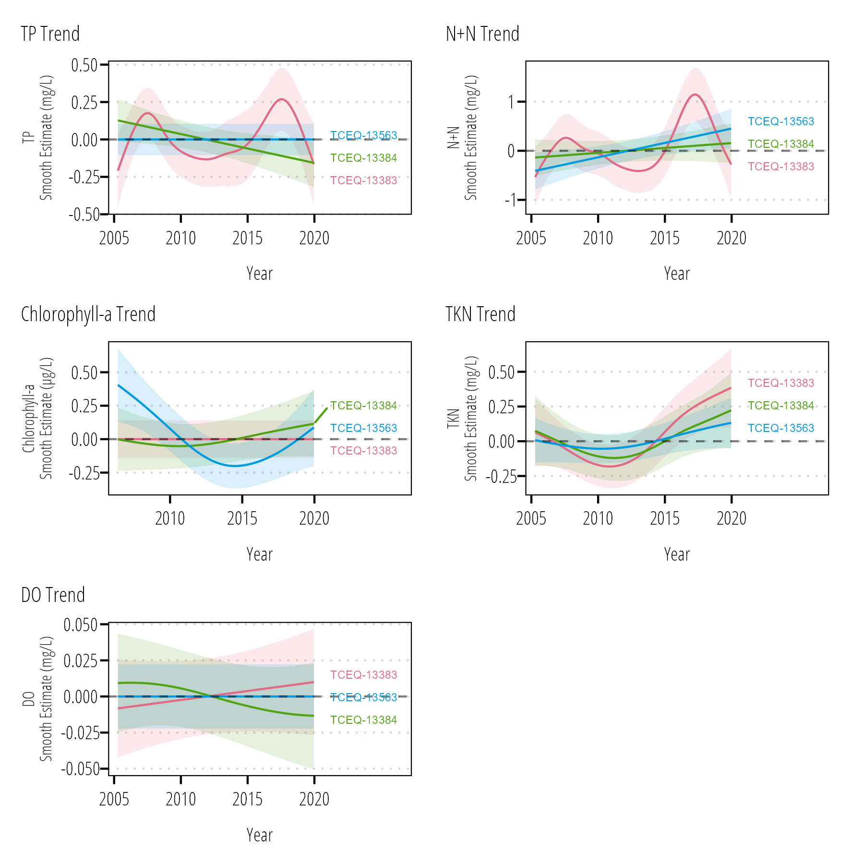

Figure . Smoothed long-term trend component from each water quality parameter and station GAM.

The long-term water quality concentration trend for each temporal GAM model are shown in Figure . Significant long-term trends in TP concentration were observed with GAMs at TCEQ-13383 and TCEQ-13384. Trends were different between the two sites, with TCEQ-13383 displaying a sudden temporary increase in TP concentrations around 2017-2018 and TCEQ-13384 showing a linear decrease from 2005 through 2020. Significant trends in N+N concentrations were observed at TCEQ-13383 and TCEQ-13563. N+N concentrations at TCEQ-13383 displayed a similar long term trends as TP concentrations with a sudden temporary increase around 2007-2008. Significant trends in chlorophyll-a concentrations were observed at one site. The observed trend indicates a large decrease in chlorophyll-a from 2005-2015 with a more recent increase in concentration towards the long-term mean. Long-term trends in TKN were observed at one site. TCEQ-13383 shows a slight initial decrease in TKN below the mean concentration, followed by increases in TKN from 2010 through 2020. Although the other sites did not indicate statistical significance, the predicted shape of the trends followed closely to TCEQ-13383. No significant trends in DO were observed between 2005 and 2020. TCEQ-13563 showed a linear increase from 2005 through 2020.

## Estuarine Water Quality Explained by Flow and Load Variability

Flow and/or nutrient terms were significant for TP and N+N models at all three Lavaca Bay sites (Table ). Chlorophyll-a models were improved by the inclusion of flow at two sites. TKN and DO models were improved by the inclusion of flow at one site. The inclusion of load did not improve Chlorophyll-a or DO models at any site.

Table . Model AICC values and associated model probabilities (in parenthesis). Models with the highest probability for each site and water quality parameter combination are bolded and italicized for emphasis.

| **Parameter** | **Site** |  | **Temporal** |  | **Flow** |  | **Flow + Load** |
| --- | --- | --- | --- | --- | --- | --- | --- |
| TP | TCEQ-13383 |  | -164.0 (0.01) |  | -169.6 (0.11) |  | ***-173.7 (0.88)*** |
| TCEQ-13384 |  | -206.1 (0.06) |  | ***-210.1 (0.47)*** |  | -210.1 (0.47) |
| TCEQ-13563 |  | -149.4 (0.00) |  | -161.3 (0.33) |  | ***-162.7 (0.67)*** |
| Nitrite+Nitrate | TCEQ-13383 |  | -191.6 (0.00) |  | ***-215.0 (0.50)*** |  | -215.0 (0.50) |
| TCEQ-13384 |  | -219.8 (0.00) |  | ***-277.5 (0.72)*** |  | -275.6 (0.28) |
| TCEQ-13563 |  | -160.5 (0.00) |  | -176.6 (0.46) |  | ***-176.9 (0.54)*** |
| Chlorophyll-a | TCEQ-13383 |  | 277.2 (0.18) |  | ***275.6 (0.41)*** |  | 275.6 (0.41) |
| TCEQ-13384 |  | ***264.3 (0.33)*** |  | 264.3 (0.33) |  | 264.3 (0.33) |
| TCEQ-13563 |  | 285.8 (0.07) |  | ***282.0 (0.46)*** |  | 282.1 (0.46) |
| TKN | TCEQ-13383 |  | ***42.2 (0.66)*** |  | 43.5 (0.34) |  | NA |
| TCEQ-13384 |  | ***29.8 (0.60)*** |  | 30.6 (0.40) |  | NA |
| TCEQ-13563 |  | 31.1 (0.22) |  | ***28.7 (0.78)*** |  | NA |
| DO | TCEQ-13383 |  | ***146.4 (0.34)*** |  | 146.4 (0.34) |  | 146.5 (0.32) |
| TCEQ-13384 |  | ***135.9 (0.47)*** |  | 137.0 (0.27) |  | 137.0 (0.27) |
| TCEQ-13563 |  | 138.3 (0.25) |  | ***137.2 (0.43)*** |  | 137.8 (0.32) |

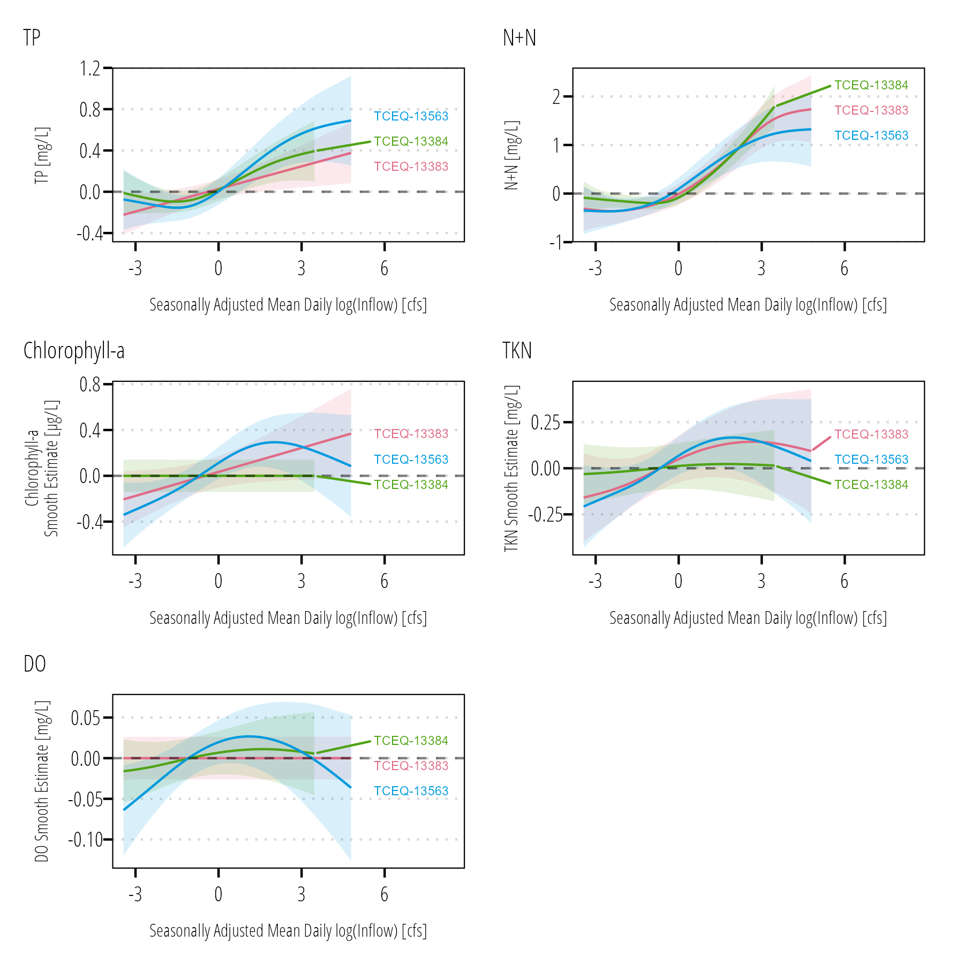

Figure . Estimated effects of seasonally adjusted mean daily inflow (response residuals from streamflow and season GAM model) on TP, N+N, chlorophyll-a, TKN, and DO concentrations in Lavaca Bay.

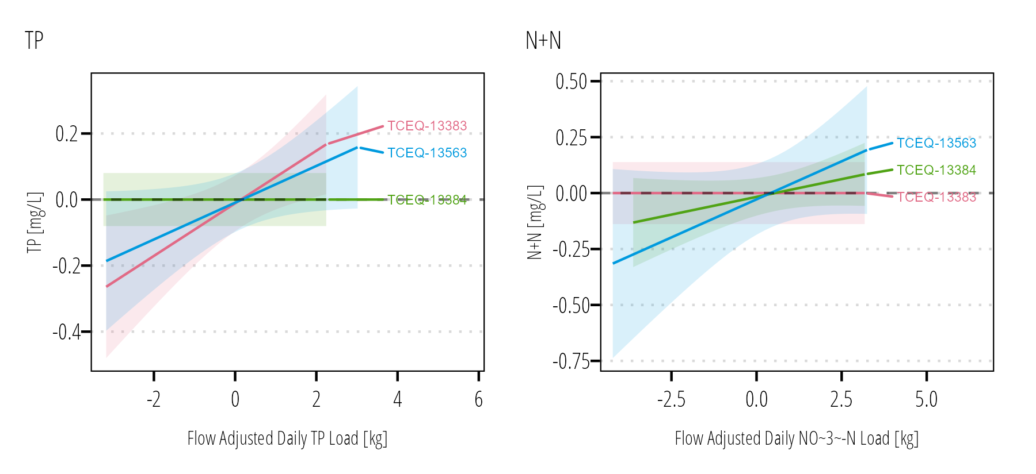

Figure . Estimated effects of flow adjusted nutrient loads (response residuals from nutrient load and flow GAM model) on TP and N+N concentrations in Lavaca Bay.

# Discussion

# Conclusion

# Bibliography

Berthold TA, Olsovsky T, Schramm MP. 2021. Direct mailing education campaign impacts on the adoption of grazing management practices. Journal of Contemporary Water Research & Education.(174):45–60. doi:[10.1111/j.1936-704X.2021.3360.x](https://doi.org/10.1111/j.1936-704X.2021.3360.x).

Beseres Pollack J, Palmer T, Montagna P. 2011. Long-term trends in the response of benthic macrofauna to climate variability in the Lavaca-Colorado Estuary, Texas. Mar Ecol Prog Ser. 436:67–80. doi:[10.3354/meps09267](https://doi.org/10.3354/meps09267).

Bugica K, Sterba-Boatwright B, Wetz MS. 2020. Water quality trends in Texas estuaries. Marine Pollution Bulletin. 152:110903. doi:[10.1016/j.marpolbul.2020.110903](https://doi.org/10.1016/j.marpolbul.2020.110903).

Burnham KP, Anderson DR, Huyvaert KP. 2011. AIC model selection and multimodel inference in behavioral ecology: some background, observations, and comparisons. Behav Ecol Sociobiol. 65(1):23–35. doi:[10.1007/s00265-010-1029-6](https://doi.org/10.1007/s00265-010-1029-6).

De Cicco LA, Hirsch RM, Lorenz DL, Watkins WD, Johnson M. 2022. dataRetrieval: R packages for discovering and retrieving water data available from Federal hydrologic web services. doi:[10.5066/P9X4L3GE](https://doi.org/10.5066/P9X4L3GE). <https://code.usgs.gov/water/dataRetrieval>.

Jain S, Ruff S, Schramm MP. 2018. Technical Support Document for One Total Maximum Daily Load for Indicator Bacteria in Arenosa Creek. Austin, TX: Texas Commission on Environmental Quality Report No.: AS-203. <https://www.tceq.texas.gov/downloads/water-quality/tmdl/arenosa-creek-recreational-108/108-arenosa-creek-tsd-final-10-02-20.pdf>.

Lloyd CEM, Freer JE, Collins AL, Johnes PJ, Jones JI. 2014. Methods for detecting change in hydrochemical time series in response to targeted pollutant mitigation in river catchments. Journal of Hydrology. 514:297–312. doi:[10.1016/j.jhydrol.2014.04.036](https://doi.org/10.1016/j.jhydrol.2014.04.036).

Montagna PA, Cockett PM, Kurr EM, Trungale J. 2020. Assessment of the Relationship Between Freshwater Inflow and Biological Indicators in Lavaca Bay. Corpus Christi, Texas: Harte Research Institute, Texas A&M University-Corpus Christi Final Report to the Texas Water Development Board Report No.: Contract # 1800012268.

Murphy RR, Keisman J, Harcum J, Karrh RR, Lane M, Perry ES, Zhang Q. 2022. Nutrient improvements in Chesapeake Bay: Direct effect of load reductions and implications for coastal management. Environ Sci Technol. 56(1):260–270. doi:[10.1021/acs.est.1c05388](https://doi.org/10.1021/acs.est.1c05388).

Palmer TA, Montagna PA. 2015. Impacts of droughts and low flows on estuarine water quality and benthic fauna. Hydrobiologia. 753(1):111–129. doi:[10.1007/s10750-015-2200-x](https://doi.org/10.1007/s10750-015-2200-x).

Schramm MP, Berthold A, Entwistle C, Peddicord K. 2018. Lavaca River Watershed Protection Plan. College Station, Texas: Texas Water Resources Institute Report No.: TR-507. <https://twri.tamu.edu/media/1456/tr-507.pdf>.

Schramm MP, Gitter A, Gregory L. 2022. Total Maximum Daily Loads and *Escherichia coli* trends in Texas freshwater streams. Journal of Contemporary Water Research & Education.(176):36–49. doi:[10.1111/j.1936-704X.2022.3374.x](https://doi.org/10.1111/j.1936-704X.2022.3374.x).

Wazniak CE, Hall MR, Carruthers TJB, Sturgis B, Dennison WC, Orth RJ. 2007. Linking water quality to living resources in a Mid-Atlantic lagoon system, USA. Ecological Applications. 17(sp5):S64–S78. doi:[10.1890/05-1554.1](https://doi.org/10.1890/05-1554.1).

# Appendix A

You can add more info, tables, and figures here.